- View the content of file f1 in vi editor : vi f1
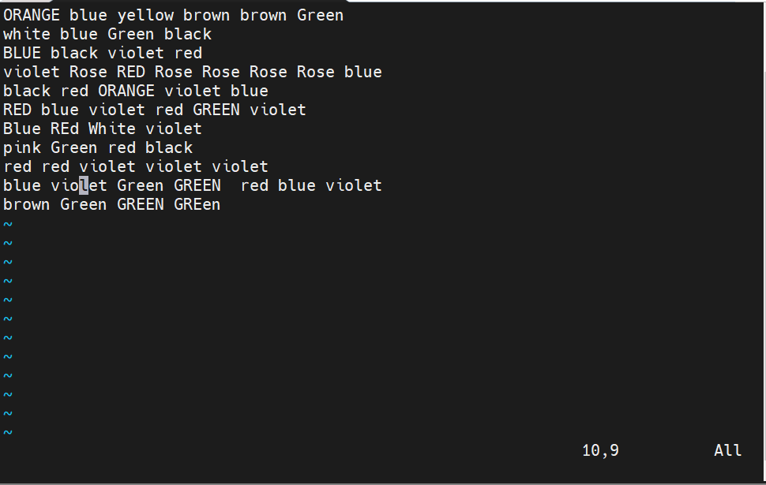
- esc x [ Delete the character where the cursor is pointing ]

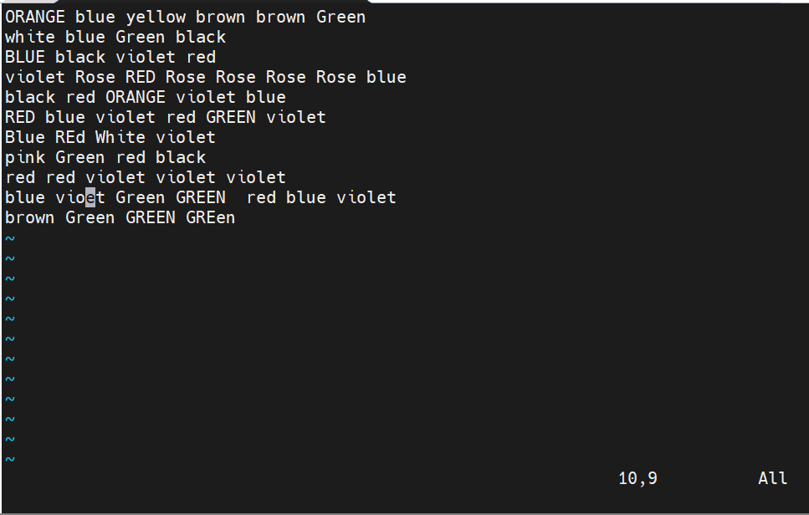

- Execute the command : esc:%s/blue/grey/g [ Replace every occurrence of "blue" with "grey" in the whole file ]
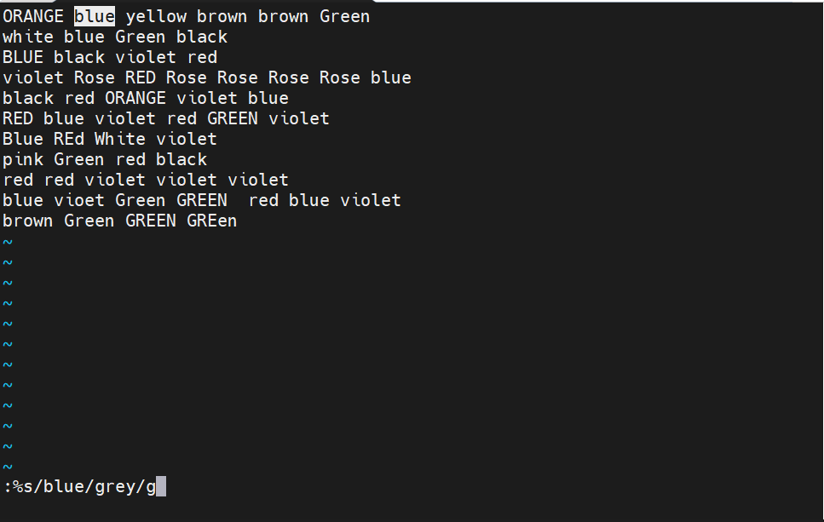

Output :
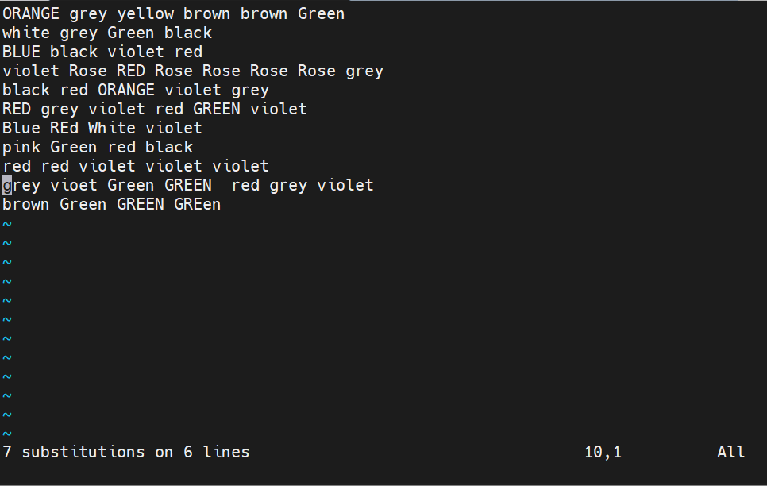

- Execute the command : esc:s/green/blue/gi [ Replace "green"/"GREEN" (case-insensitive) with "blue" on the current line only ]
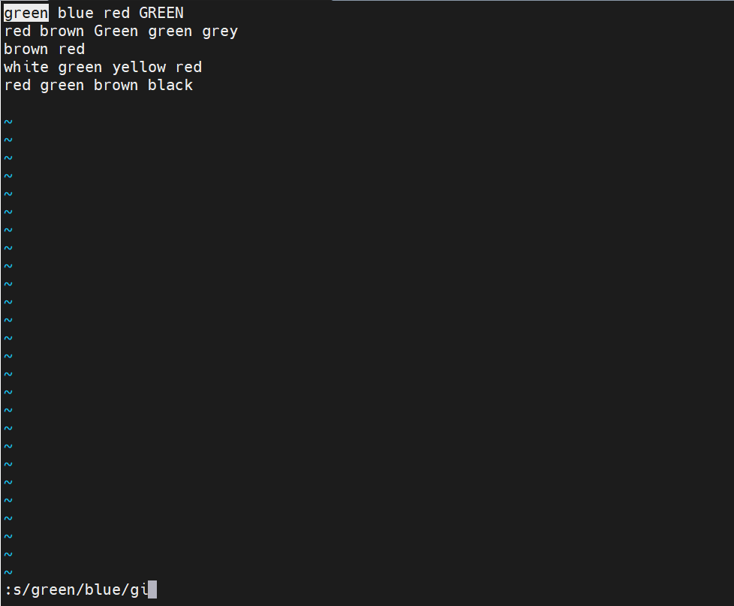

Output :
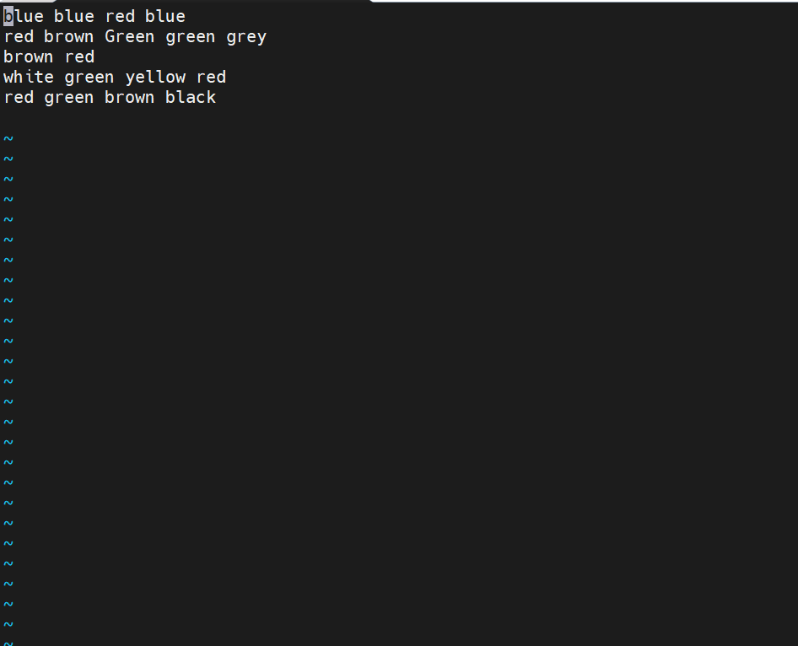
- Execute the Command : esc:%s/green/blue/gi [ Replace "green"/"GREEN" (case-insensitive) with "blue" throughout the whole file ]
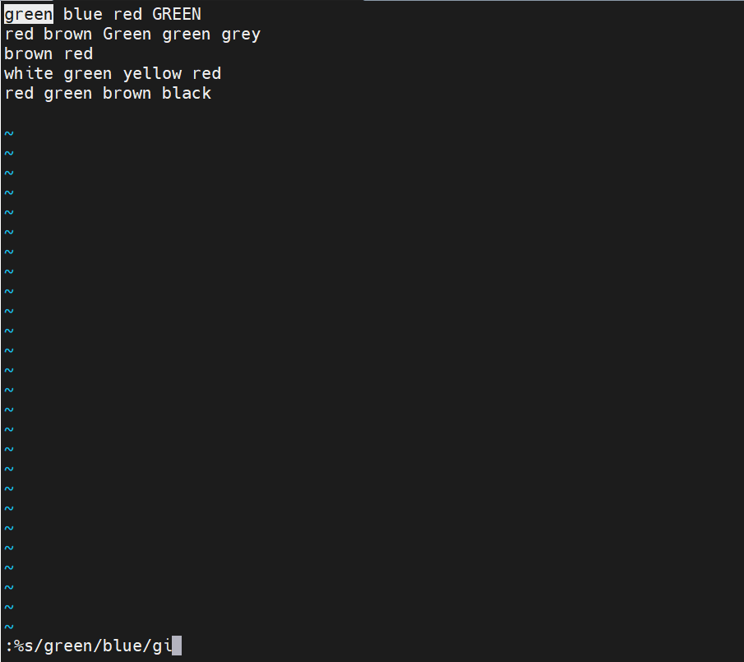

Output :
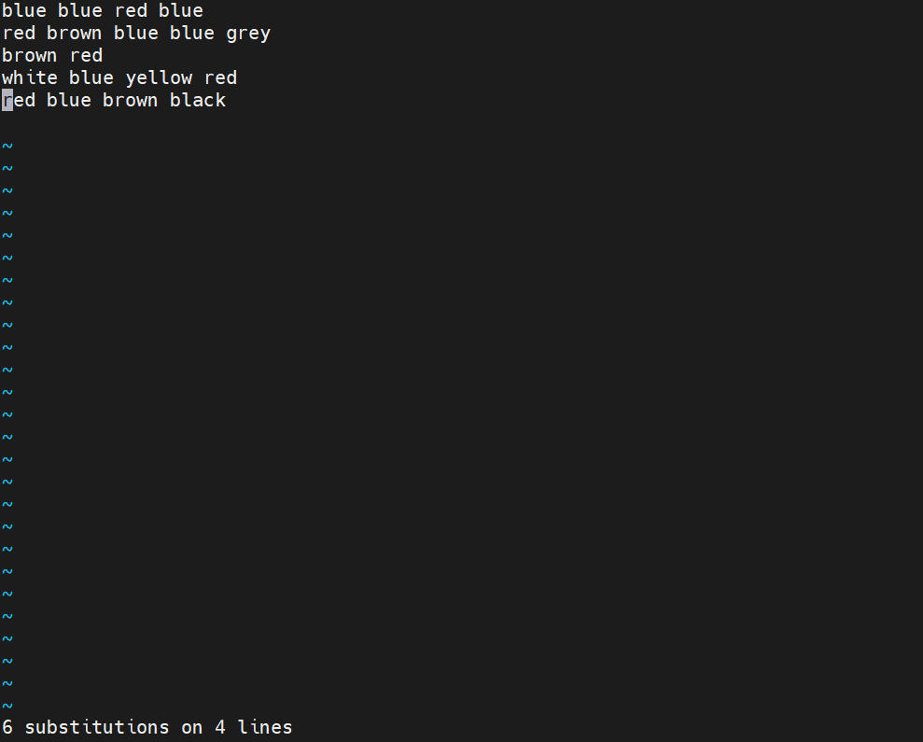
- Execute the following commands to create and view files using echo and cat
- echo Welcome [ display text on the screen ]
- echo HELLO >f1 [ redirect and overwrite content of f1 ]
- cat f1 [ view content of f1 ]
- echo "good morning" >f1 [ overwrite f1 with new content ]
- echo "Have a nice day" >>f1 [ append content to f1 ]
- echo Welcome all >f2 [ create file f2 ]
- echo Practice makes a man perfect >>f1 [ append another line to f1 ]
- cat f2 f1 [ view content of f2 followed by f1 ]
- cat -n f1 [ view content of f1 with line numbers ]

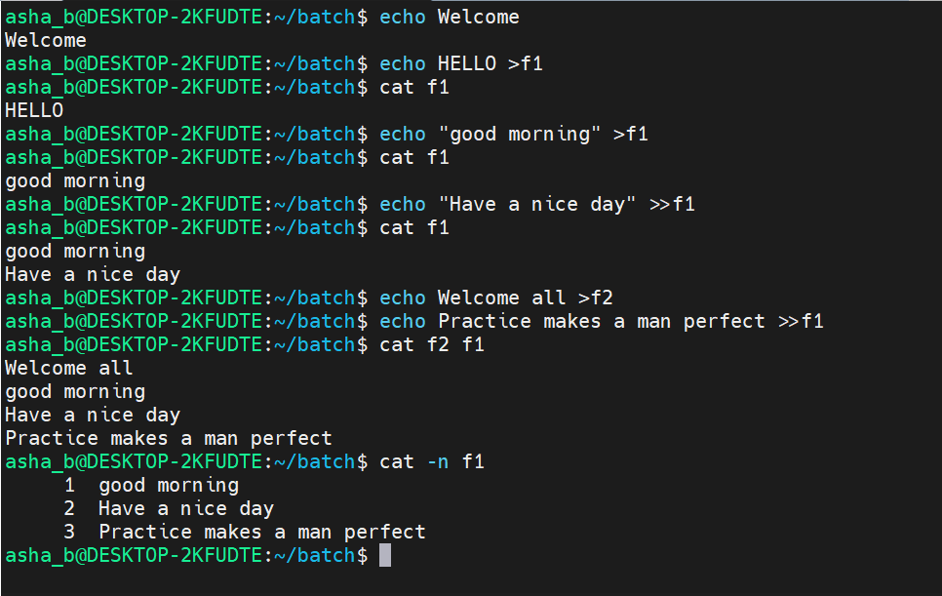
- Execute the command :
- vi f1 [ insert blank lines at 3, 4, 5, 6 ]
- cat -n f1 [ numbers all lines, including blank lines ]
- cat -b f1 [ numbers only non-blank lines ]
- cat -s f1 [ squeezes multiple blank lines into a single blank line ]
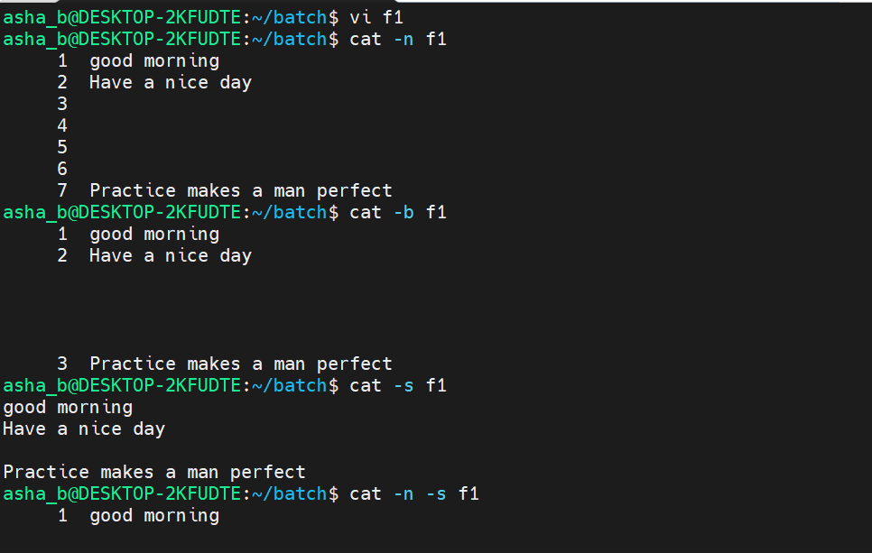
- Execute the command :
- Execute the command : cat -n -s f1 and
- cat -s -n f1 [ combine numbering with squeezing blank lines, in either flag order ]

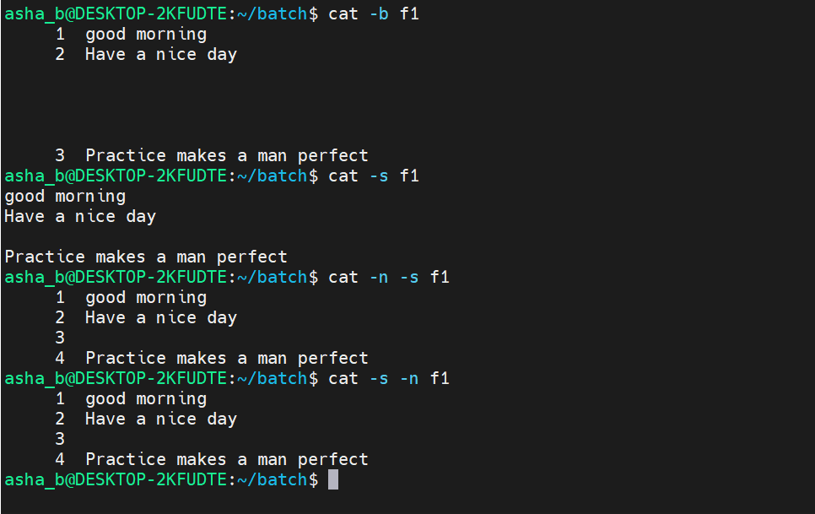
- Execute the command :
- cat -n -b f1 [ combine numbering non-blank lines with squeezing blank lines ]
- cat f1 f2 [ view content of f1 followed by f2 ]
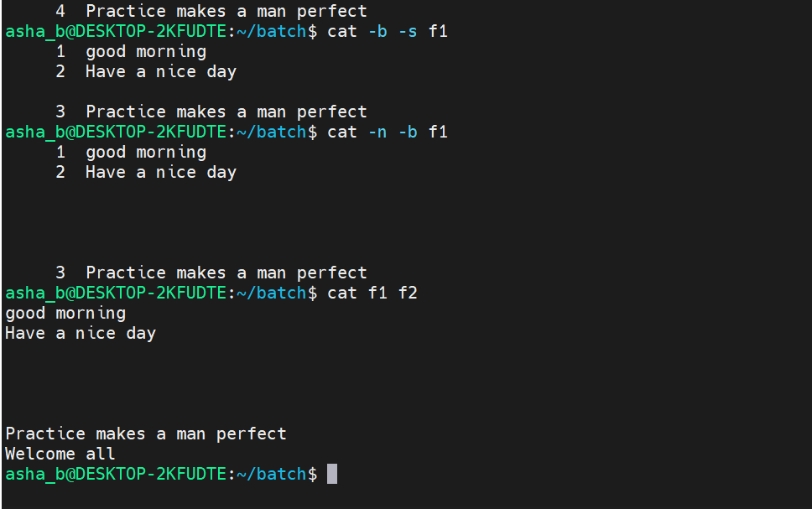

- Execute the command : esc:%s/good/evening/gc [ Replace "good" with "evening" only the 4th occurance throughout the file, prompting for confirmation before each replacement ]

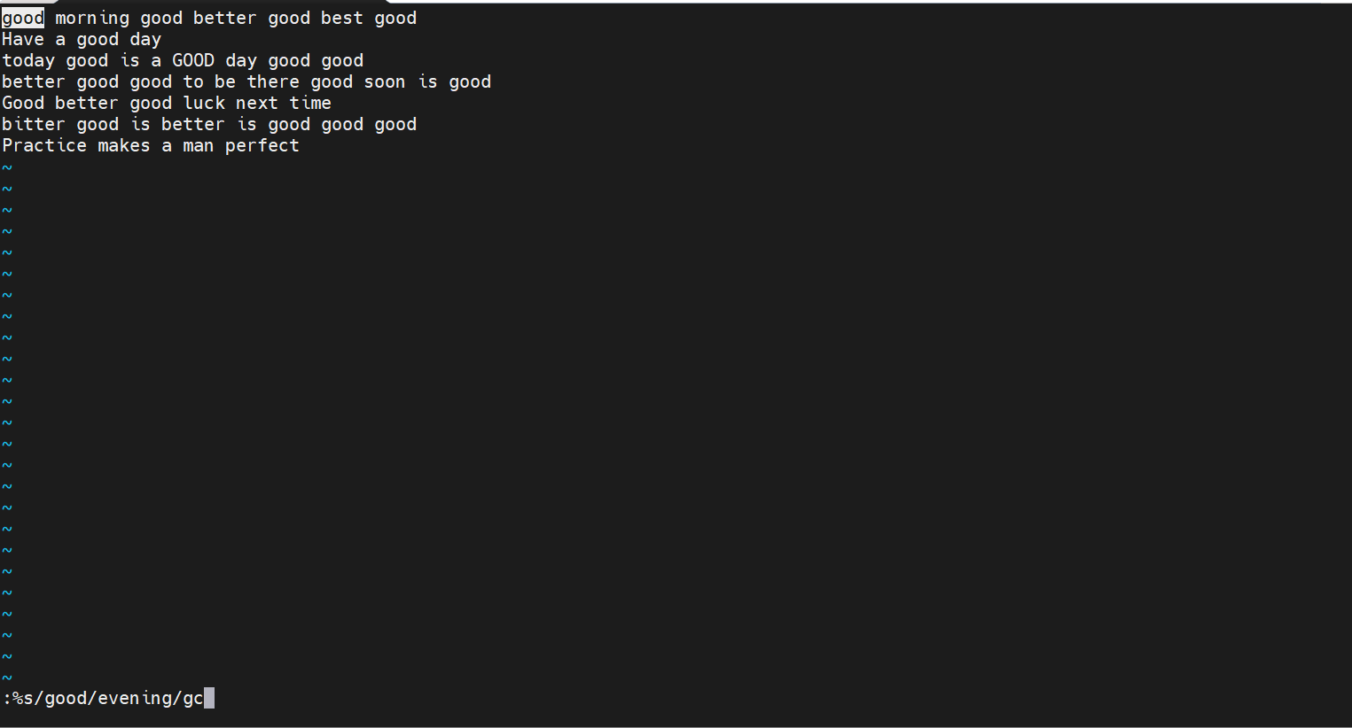
- y / n / a / q / l [ Confirm, skip, replace-all, quit, or replace-last-and-quit at each prompt ]
